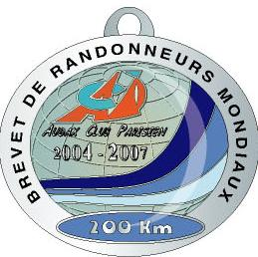
AUDAX CLUB PARISIEN

SUPER RANDONNEUR

MEDAL APPLICATION FORM
(to be filled in block letters PLEASE)

RANDONNEURS FRANÇAIS 1921
RANDONNEURS EUROPEENS 1976
RANDONNEURS MONDIAUX 1983

Nome ……………………………..….…… Sobrenome ……………….…………….… Data nascimento …. / …. / ……..…

Endereço……………………………………..……….…………………………….…………………………………………………………………

CEP …………..………. Cidade …………………….……………..….…………….……Estado …………...………………… Brasil

Clubee Nome…….……………………………………………………………………….……….……Codigo ACP do clube ……..……..…
(NO abbreviations)

Organization | BREVET | Date | Organizer  or name of the event | * ACP Brevet Number
Brevets de  Randonneurs  Mondiaux | 200
Brevets de  Randonneurs  Mondiaux | 300
Brevets de  Randonneurs  Mondiaux | 400
Brevets de  Randonneurs  Mondiaux | 600
* The ACP Brevet number can be found on the ACP sticker on your returned Brevet card.

